Intermediate Algebra Lecture 10.7: An Introduction to Operations with Complex Numbers

Is the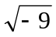 Possible? Maybe? Depends on the number system!

Imaginary Numbers
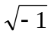 is defined as the number “i”
Or ‘i’ is defined as the square root of (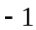)

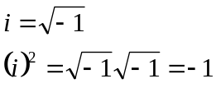

*This lets us rewrite the square roots of negative numbers

WARNING PRODUCT RULE does NOT work imaginary numbers only Real Numbers

Example
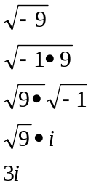

Example
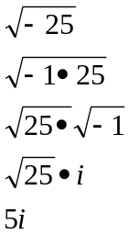

Example
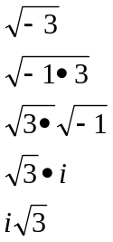
Example
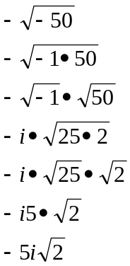

Example
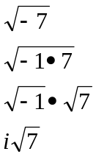

Example
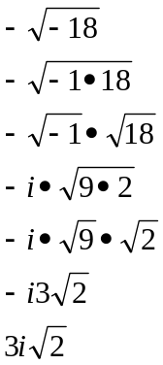

Example
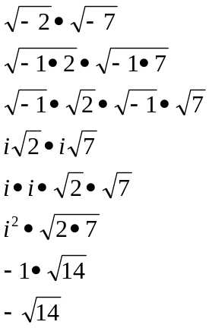

Example
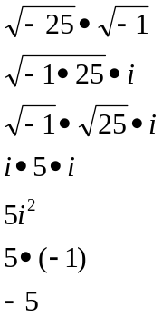

Example
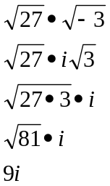

Example
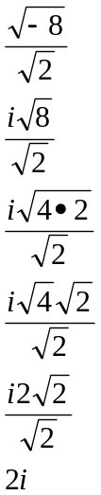

Example
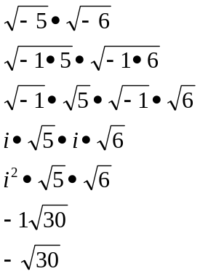

Example
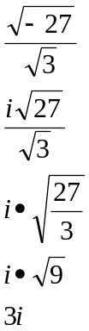

Complex Numbers
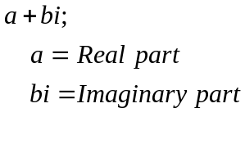
All numbers are complex numbers
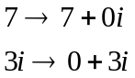

Add/subtract complex numbers
Exactly like combining like terms

Example
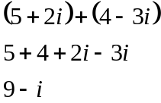

Example
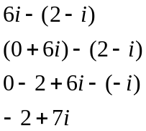

Example
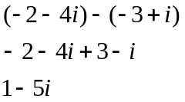

Example
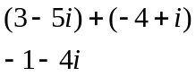

Example
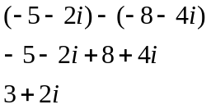

Example
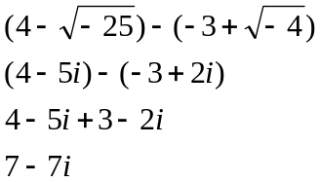

Multiplying complex numbers
*Note 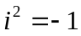

Example
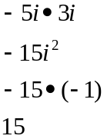

Example
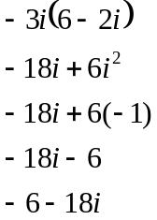

Example
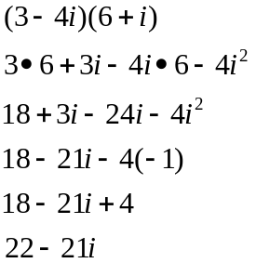

Example
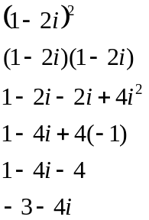

Example
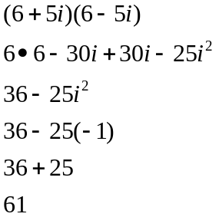

Example
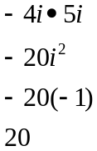

Example
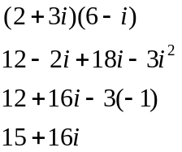

Example
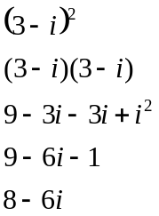

Dividing complex numbers
Multiply by the conjugate of the denominator

Example
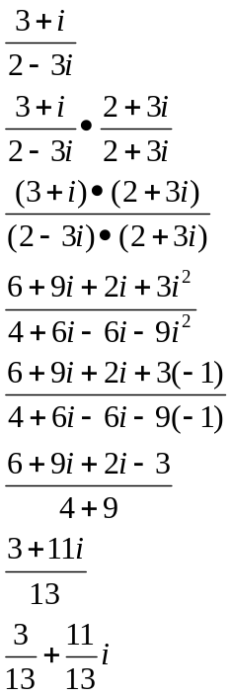

Example
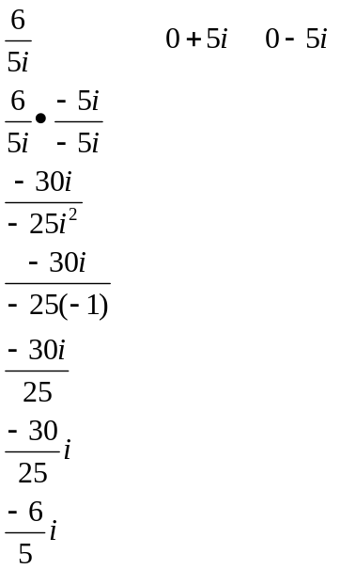

Example
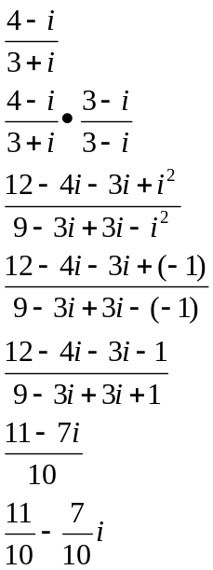

Example
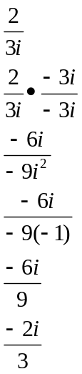
Powers of i
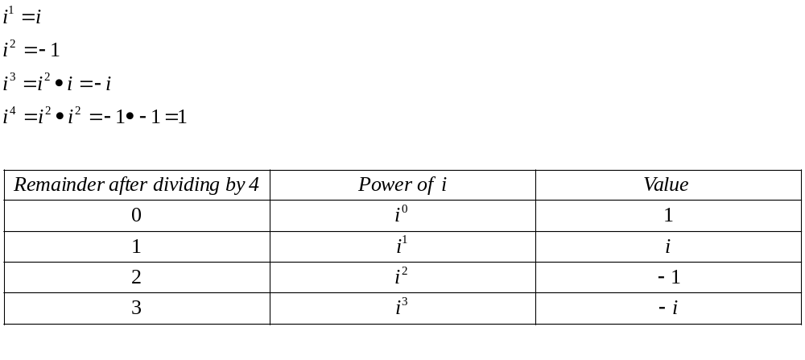

Another way to think of this process of simplifying powers of i is to divide the exponent by 4,
- if the remainder is 0, the answer is 1 (i0).
- if the remainder is 1, the answer is i (i1).
-if the remainder is 2, the answer is -1 (i2).
-if the remainder is 3, the answer is -i (i3).

